Powered by AI

You
Are gorillas monkeys?
Copilot
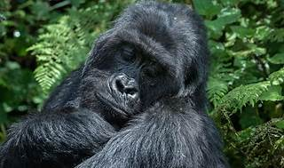
No, gorillas are not monkeys. Gorillas belong to a different group of primates known as apes. This group also includes humans, chimpanzees, bonobos, orangutans, and gibbons^1^^2^.
Here are some key differences:
- Classification: Gorillas are classified as apes in the family Hominidae, while monkeys belong to various other families within the primate order^2^.
- Physical Traits: Gorillas are generally larger and heavier than monkeys. They also lack tails, which most monkeys have^3^.
- Behavior: Gorillas are predominantly ground-dwelling, whereas many monkeys are more arboreal (tree-dwelling)^4^.
If you have any more questions about gorillas or other primates, feel free to ask! 🦍
Learn more: 1. leozoo.org 2. mrcsl.org 3. thisvsthat.io 4. en.wikipedia.org 5. medium.com 6. www.britannica.com 7. www.gettyimages.com

Conversation by Fifa Utuber with Copilot on Saturday, Sep 28 2024

